Tine Weeder Concepts
Thaddeus Hughes
23 AUG 2024

I. Framing Concepts
The tine weeder would need a frame that supports adjustment of the two gangs of tines.
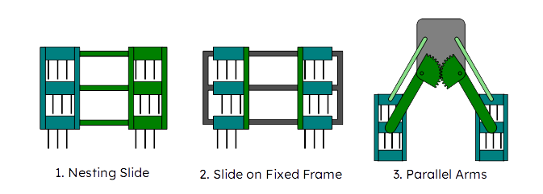

1. Nesting Slide
Here the left (teal) and right (green) gangs slide together.

2. Slide on Fixed Frame
Here the left and right gangs (teal) slide independently on a fixed frame. A bar or frame would link each row of tines - the bars that synchronize the pitch of the “rows” of tines could be strengthened to serve this purpose as well.

3. Parallel arms
Here a parallel linkage with a gear mesh (green) keeps the left and right gangs (teal) evenly spaced and parallel.

II. Adjustment Concepts

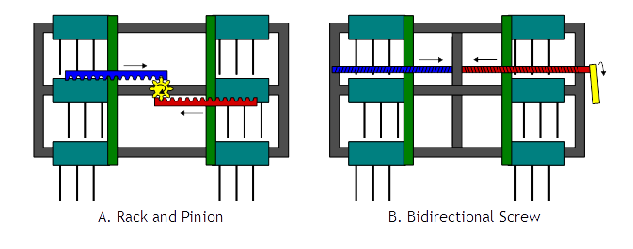
A. Rack and Pinion
Here a pinion (yellow) engages racks (blue and red) which are attached to the tine gangs.

B. Bidirectional Screw
A bidirectional screw (that is, one half being left-handed and one half being right-handed) is mounted on bearings so that it can spin but not slide on the frame. Nuts on the tine gangs engage with the screw, so when the screw is spun (either with a motor, drill, or crank) the gangs move.
It may be possible to use the screw as the pivot point for the tines as well, eliminating a frame member.

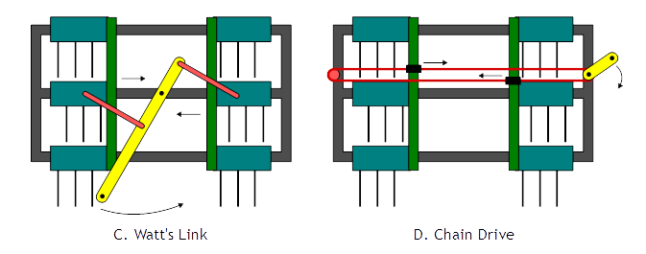
C. Watt’s Link
Here a linkage is driven by hand to move the gangs of tines in and out.

D. Chain Drive
Here a chain (red) is driven by a crank, drill, or motor (yellow). The two different sides of the chain are linked to the tine gangs so that they move opposite each other. This could also use a timing belt instead of a chain.

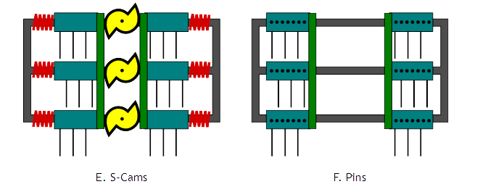
E. S-Cams
Springs push the gangs towards the center. An S-cam pushes the gangs outwards. Width is set by changing the rotation of the S-cam. Multiple S-cams could be used along the same shaft, or just one. Springs could also be extension springs run between the two gangs.

F. Pins
The gangs can be slid around and a pin in a series of holes can be used to register the gangs in a location. These pins could be vernier-style to maximise adjustment resolution.

III. Evaluation
The Slide on Fixed Frame (2) seems to be the most robust and simple option for framing, hands down.
The different adjustment mechanisms have their own advantages and disadvantages.
In all of the adjustment schemes, a locking pin would be beneficial to prevent movement during operation.
Here is a table highlighting some of the qualities of each concept:
 | A  Rack & Pinion | B.  Bidir. Screw | C.  Watt’s Link | D.  Chain Drive | E.  S-Cams | F.  Pins
Robustness | Jams Easily | Could get tight | Good | Possible jamming | Excellent | Excellent
Special parts | Gears, Racks | LH screw | None | Chain | Cam, Springs | None
Speed | Fast | Slow | Very fast | Fast | Fast | Fussy
Acutator-Ready | Yes | Yes | Somewhat | Yes | Somewhat | No
Backlash | High | Low | Low | Some | Zero | Low
Other concerns |  |  | Limited stroke |  | Pent-up energy, very limited stroke
Other benefits |  | Super-fine adjustment | Very obvious position indicator |  | Easy to drive each row of tines individually

The Watt’s Link, if it can provide enough stroke, is a great concept for manual adjustment.
If only very minimal adjustment is needed, the S-Cam concept is relatively simple and practically eliminates any backlash.
A more actuator-ready pick would be the chain drive concept.
Concepts B and F could lend themselves to controlling each row of tines independently (with three bidirectional screws, or with pinning each set of tines on their own).

IV. Tines
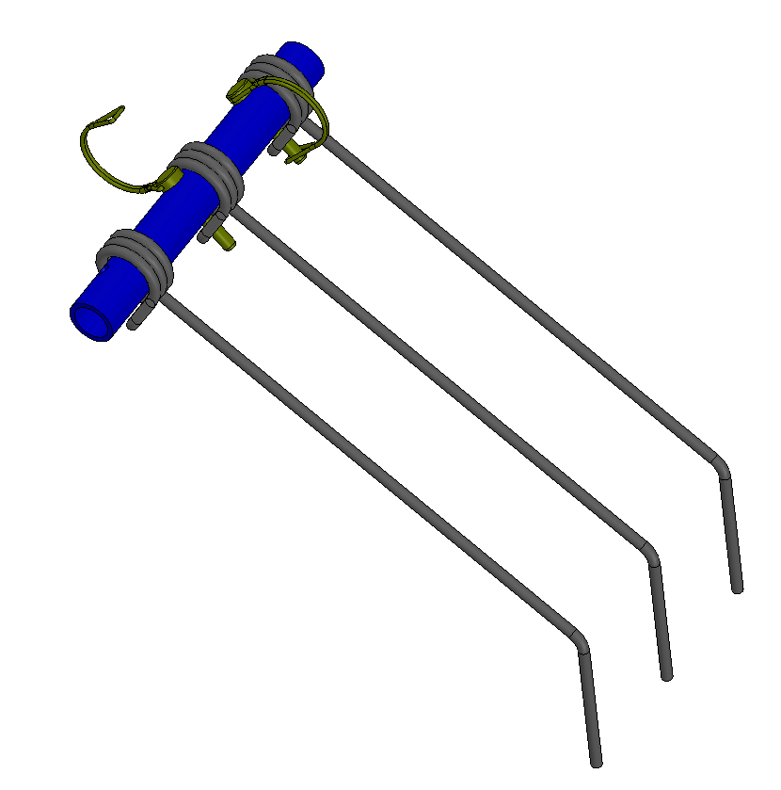
Tines don’t have to be mounted in channels. They could be mounted over round tubes and pinned in place as shown below. If the end was captured, this would make adding/removing a tine difficult, though. They could be rotated up and out of the way and pinned into a different set of holes.
In fact… There must be a million ways to mount tines. Einboeck and Treffler both have some slick ideas. Are they under patent?
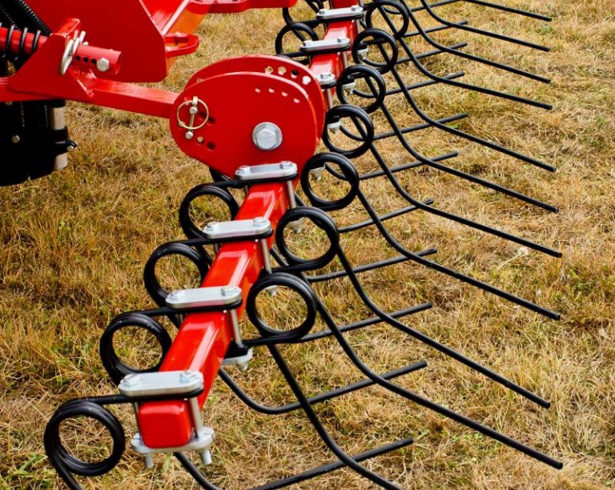


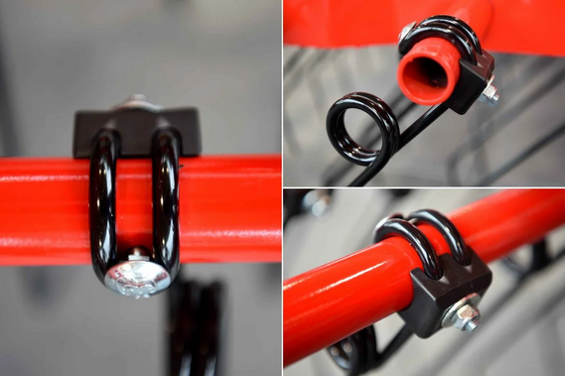

V. Spring Pack Ideas

1. Extension Spring
Use an extension spring rather than a compression spring. This would eliminate the spring pack weldment altogether and allow very easy selection of different springs (by farmers/end users even). Use an eye bolt with enough thread so that pretension adjustment can still be performed.
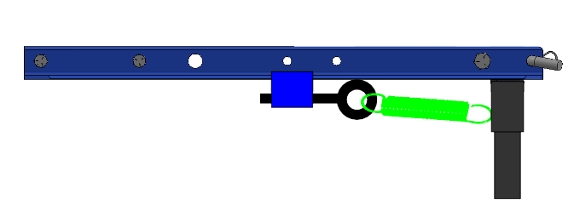
The extension spring could also be located on the top rear or even vertically (I realize now that A305 Double Hoe Option would not work with extending the receiver downwards).
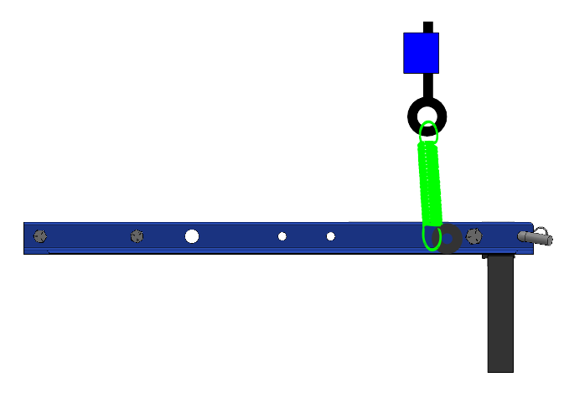

2. Inverted Compression Pack
The left side of this pack would be connected to a pivot point on the row unit. The right side would be connected to the Receiver. To adjust spring preload, the nut on the left would be tightened. To change springs the assembly could simply be taken apart and a new spring inserted.
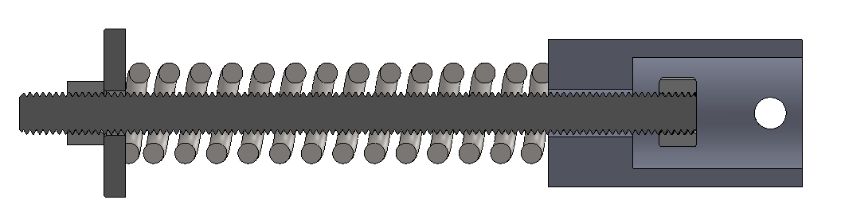

3. Inverted Compression Pack, Rigid Mount
Very similar idea, but instead, the internal rod is mounted to the frame at both ends. A “piston” arches over one end support. The reciever then presses on the piston.

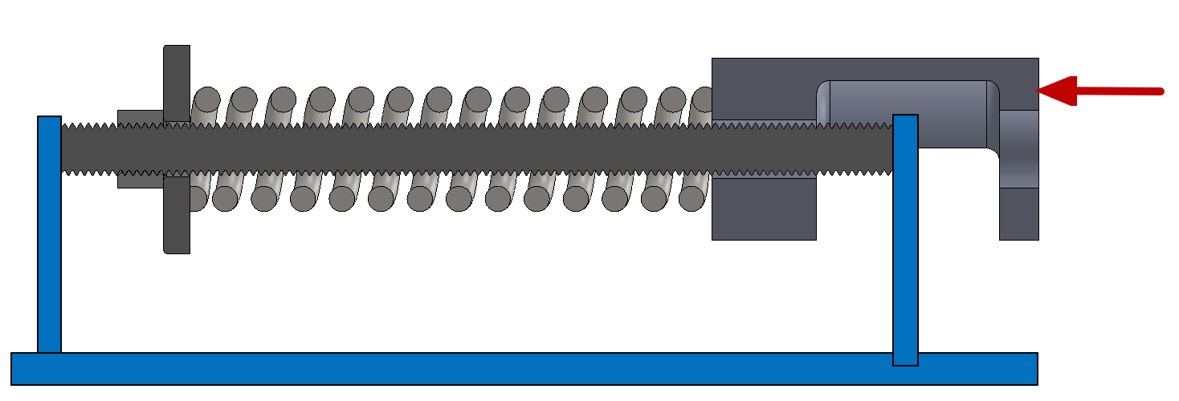
4. Compression Spring with Internal Rod and Trunnion
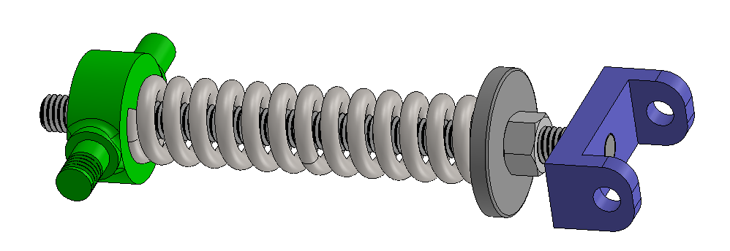
Trunnion (green) is mounted to frame (and allowed to pivot). Clevis (blue) retains the same mounting to the reciever. The nut can be used to tighten the compression spring.

VI. Questions
- What attachments may be used on the rotary hoe simultaneously?
  - In particular, will the cutaway disc ever be used in conjunction with other attachments?
- Do all attachments ones in the rear receiver all use the spring pack, or do some keep the receiver in the fixed position?
- What range and increments of adjustability are desired on the tine weeder?
- Is it OK that the tines on the tine weeder all swing up as a unit? This would cause the front tines to dig in more than the rear. It seems that the tine weeder should NOT be allowed to pivot up except as a means of preventing damage… the springing should be from the tines themselves.

