Swinging Spider Actuation Update - 23-FEB-2024

Design Overview
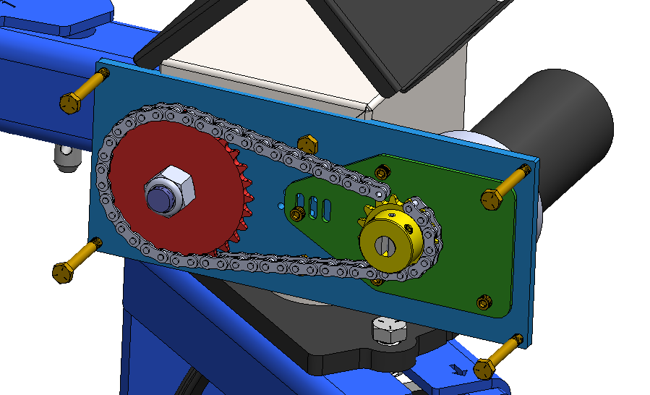

- Motor drives a #35 chain-and-sprocket drive. This sprocket drive will give some ratio adjustment, helping understand what speeds will be appropriate.
- Green plate has adjustable position to set chain tension. A “vernier caliper” style set of holes locks this plate in place.
- Purple shaft is different than the existing shaft – it has a keyway to interface with the sprocket.
- Cover designed, bolts over top.
- BOM created

Erratta from Farm Machinery Show
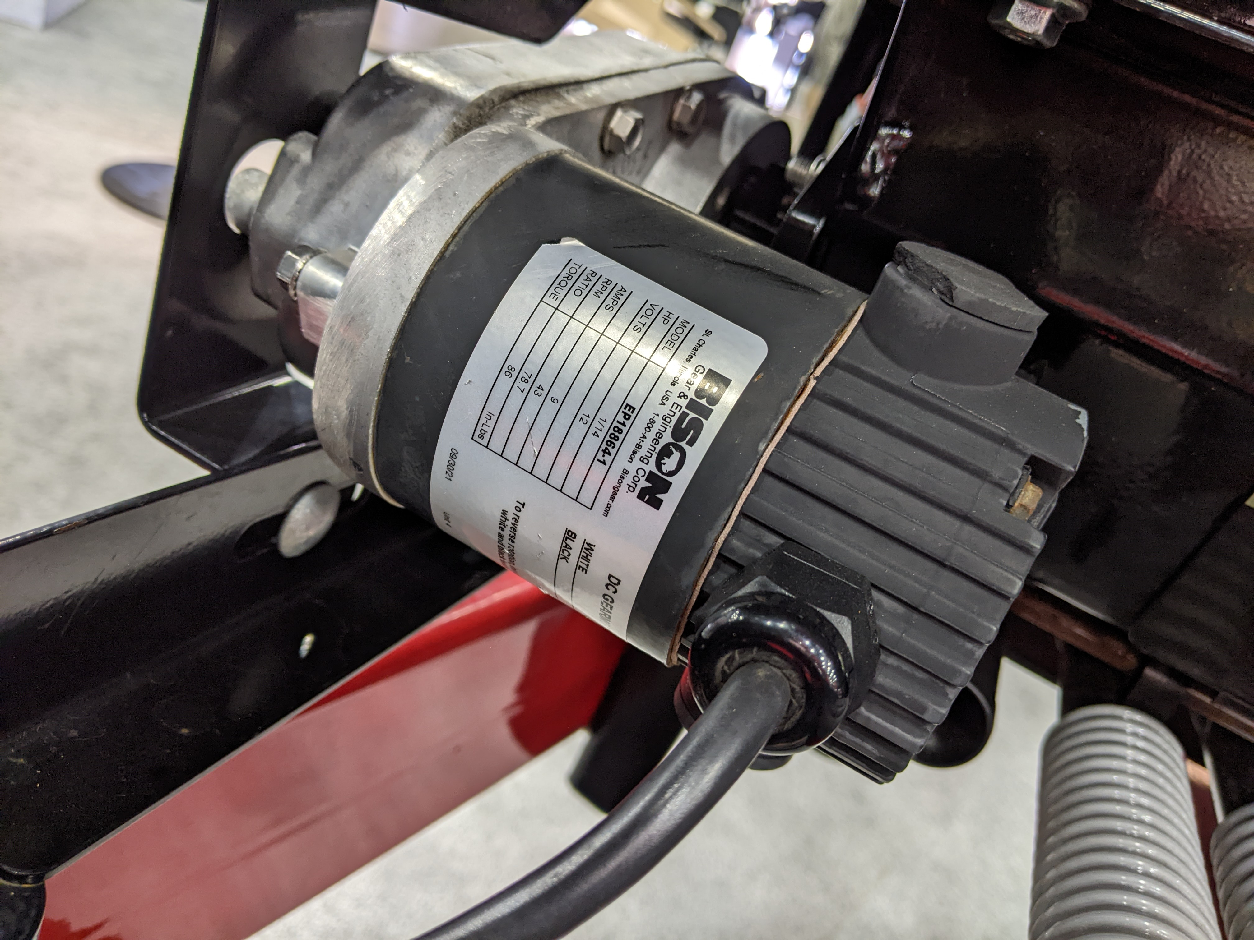
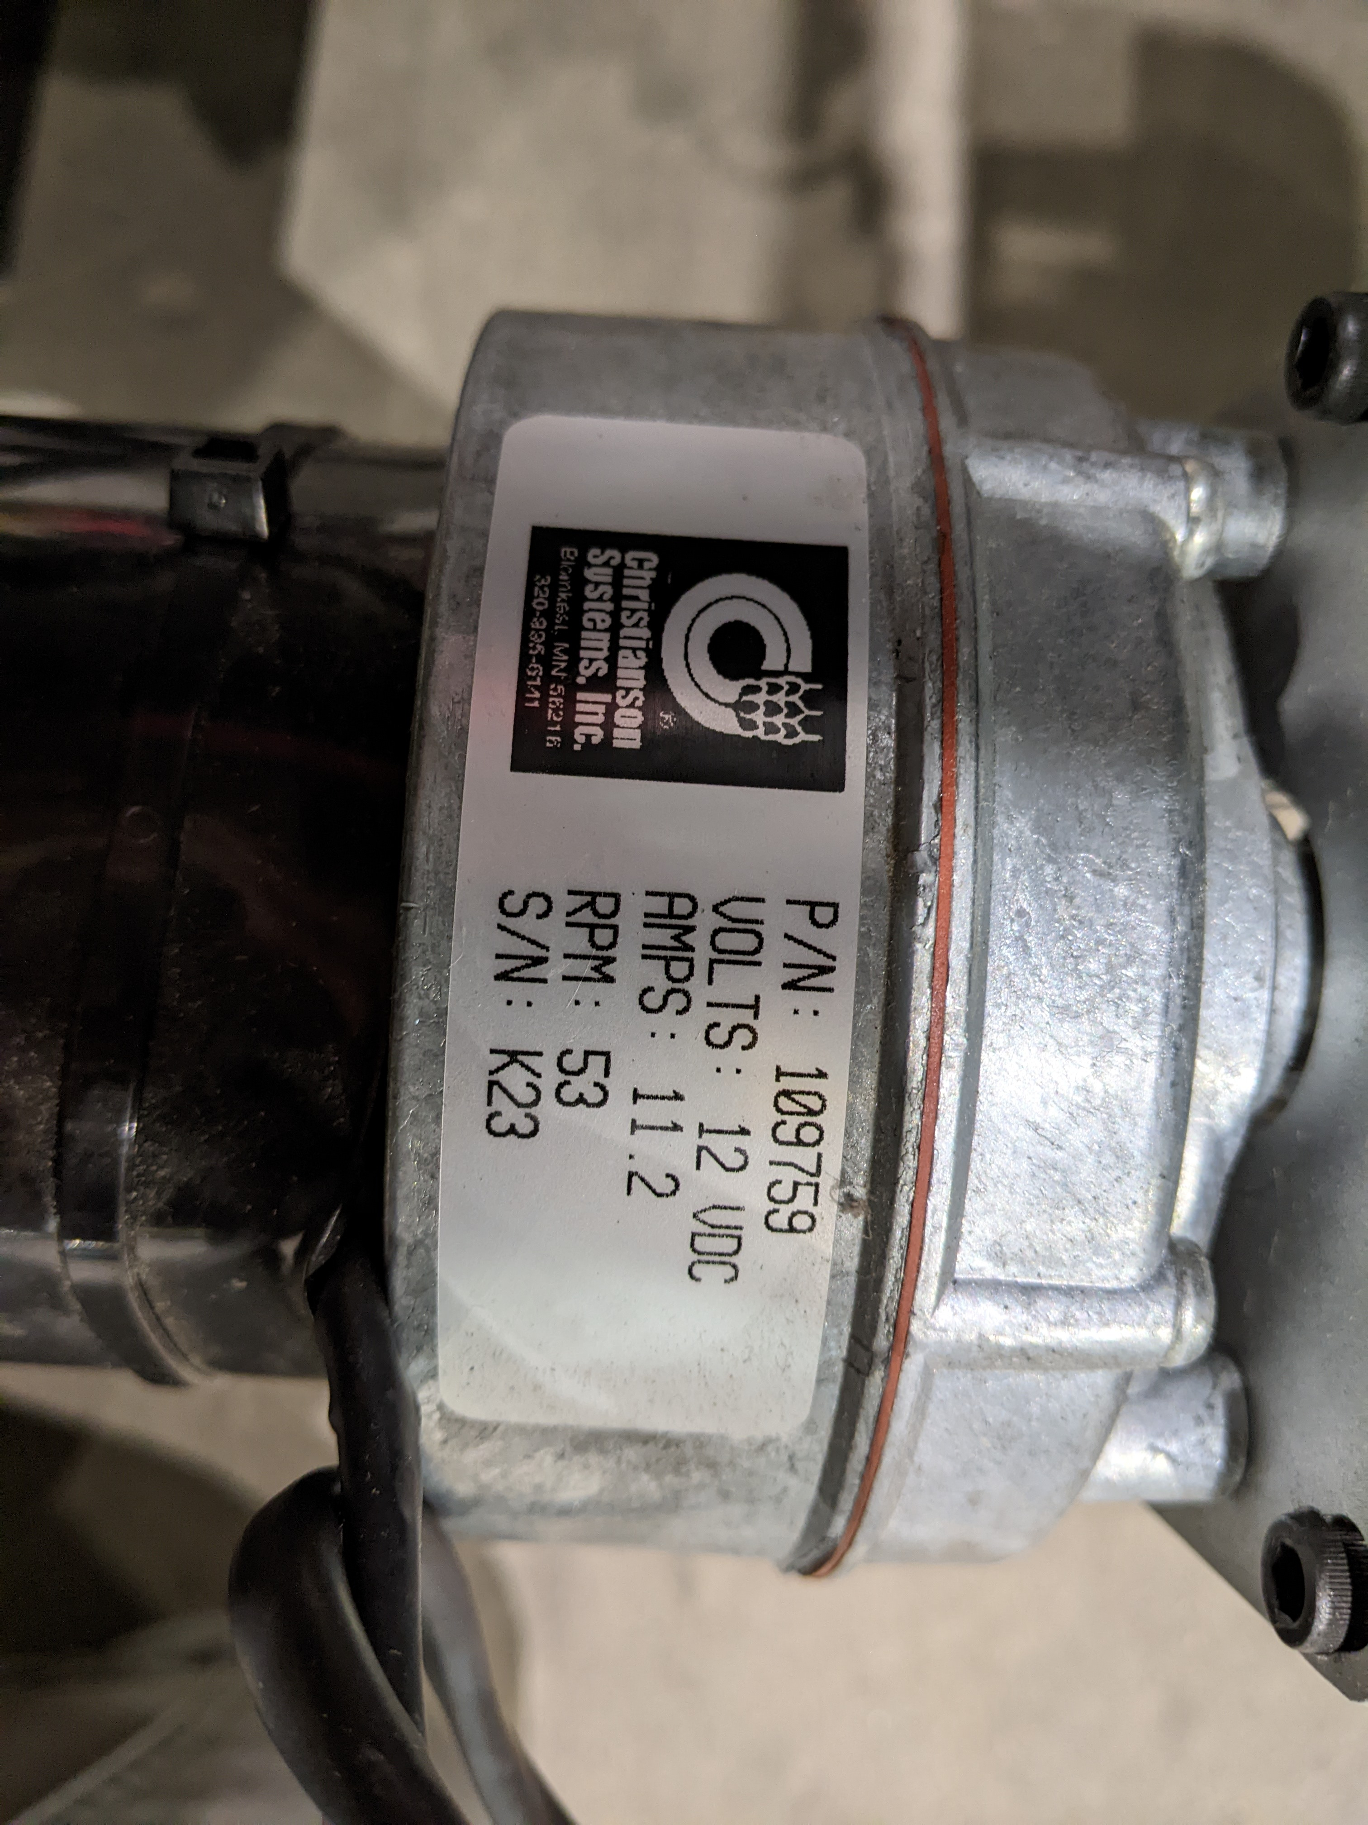
- While snooping around at the Farm Machinery Show in Louisville, I ran across this sleek unit. This may be something more final-product worthy. There isn’t enough offset in this package and it’s a custom-order unit anyways, but making a package like this could be worthwhile down-the-road once we know what gear ratios will be suitable. BISON is a child company of AMETEK, and they have manufacturing in St. Charles, IL. I think they call this motor a “hollow shaft offset gearmotor” (https://www.bisongear.com/products/hollow-shaft-offset-gearmotors.html) – I tried putting their options into CAD, but they just don’t quite fit.
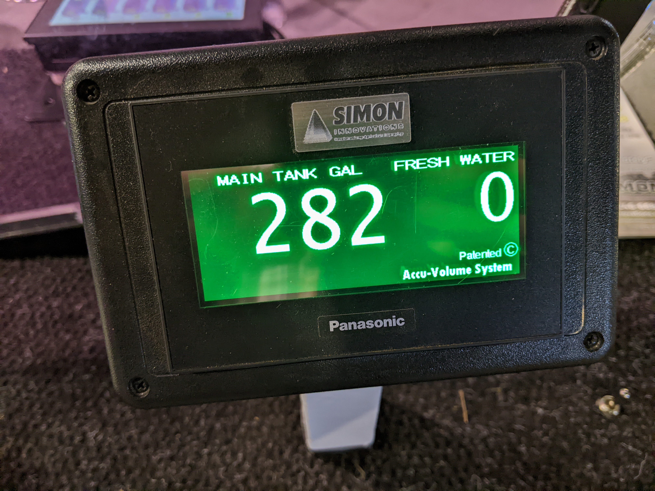
- I also found this motor in use on some equipment, which seems to be another C800 clone.
- I was on the eye for off-the-shelf displays for the future. I saw this one that had a Panasonic logo still on it. I haven’t looked into what all it offers.

