Swinging Spider Actuation Update - 25-MAR-2024

Sensor Selection Overview
I looked at a number of different promising sensors:
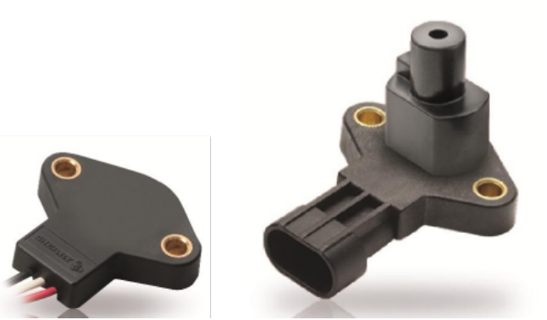
- Vishay 981HE series
- Amphenol MSC-360
- ZF (formerly Cherry) AN8 Series
All of these are hall-effect technology and act as analog output, with continuous rotation, and have mounting options. All are in the $40-70 price range. The ZF AN8, though, decouples the magnet from the switch, so it is truly contactless. Thus, vibration and impact would not be translated to the sensor, improving life and reliability.
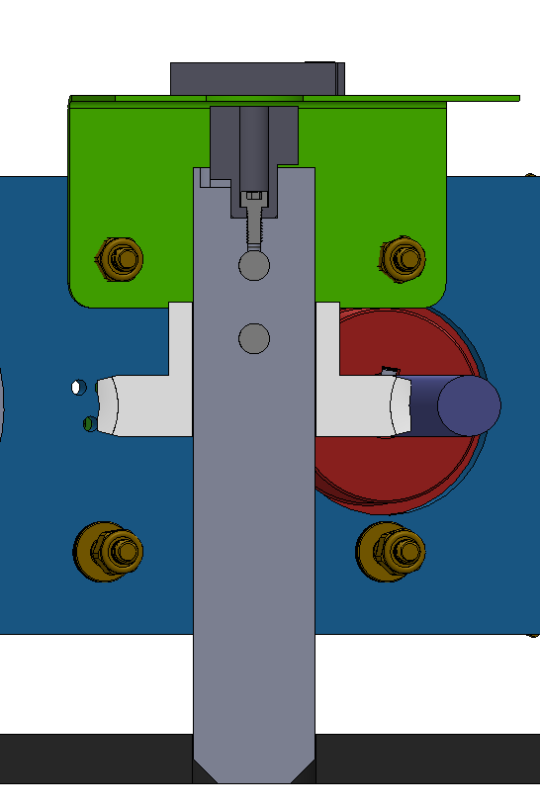
A bracket (green) to hold the sensor, along with the requisite modifications to the shaft, as well as the addition of a backup bolt, is drawn below. The magnet (actually an arrangement of magnets in a plastic housing) is attached with a #8 machine screw.


