Swinging Spider Actuation & Rotary Hoe Pro Sensing Update
Thaddeus Hughes
20 APR 2024
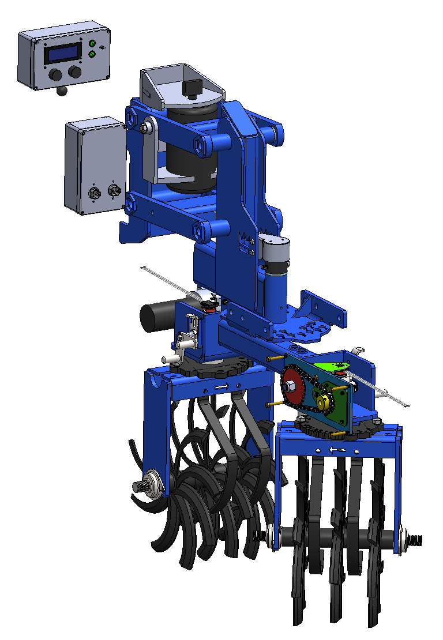

Swinging Spider Sensor: ANG11
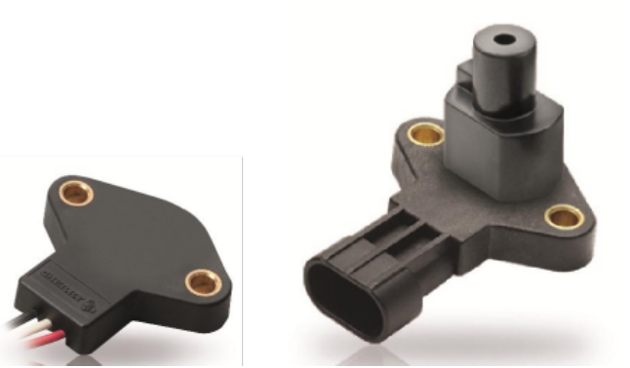
I received samples of a few different interesting sensors. Two in particular are useful:
- ZF ANG11-HAW1
- PIHER PS2P series
I think the ANG11 is the right pick.
Both of these are non-contact sensors (they read an external magnet). It doesn’t have to be the manufacturer’s magnet.
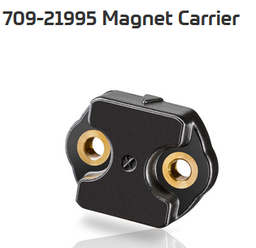
The PS2P comes in a lot of different options, gives a clear signal when it has lost reading of the magnet, and includes the magnet, but it is a bit bigger and nearly twice the price ($60 versus $35). This standard magnet also doesn’t quite attach to a 1 1/4” shaft with a circlip (the bolts would run into the circlip). This sensor cannot fit in the worm wheel box on its own bracket without modifying the cover. It could fit by simply being mounted to the cover, if the cover were secured on the front side as well.
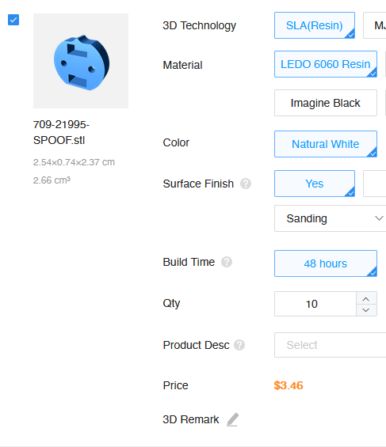
The ANG11 could interface with ZF’s 709-21995 carrier in a great low-profile package, but this carrier isn’t available from suppliers yet. In speaking with a sales rep, ZF can provide a few of these initially. I’m not sure what their long-term plan is. In the worst-case scenario, we can 3D print our own magnet carrier. This sensor can fit in the worm-wheel gearbox easily.
The swingarm uses the same sensor with some bracketing.

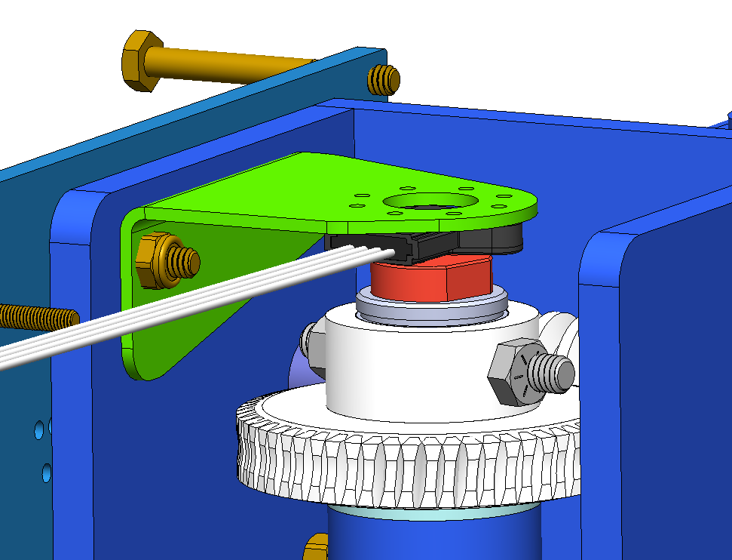

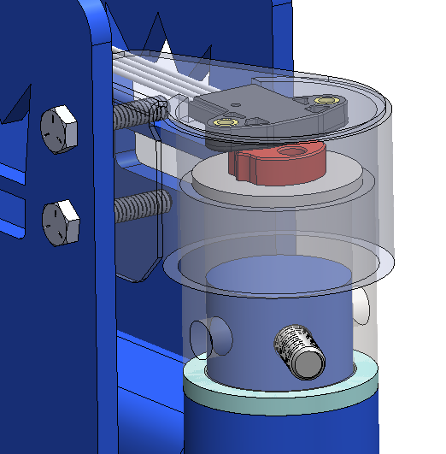
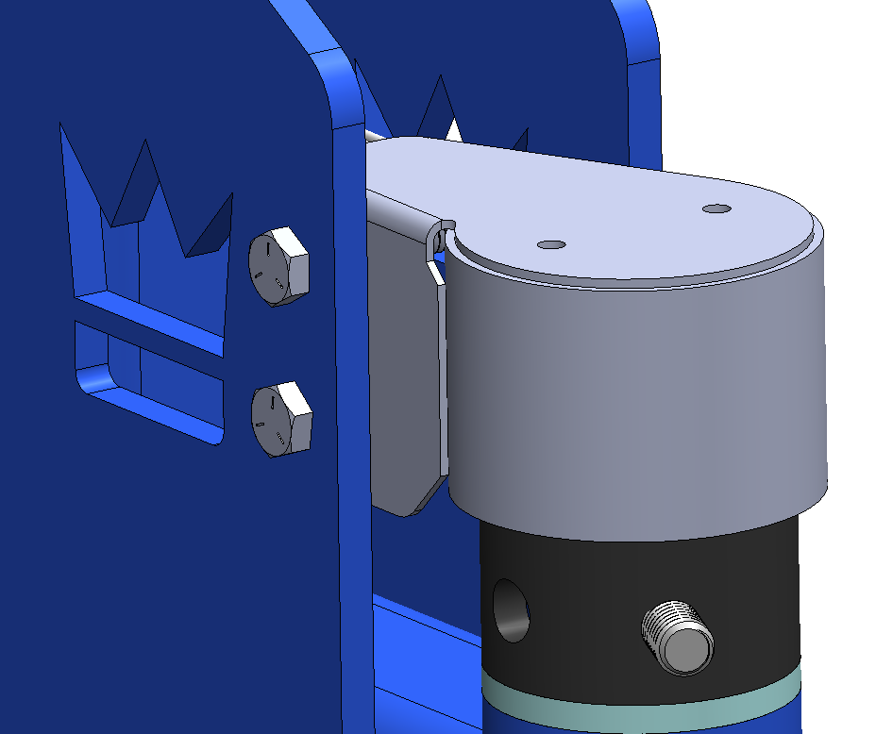

Row Control Module
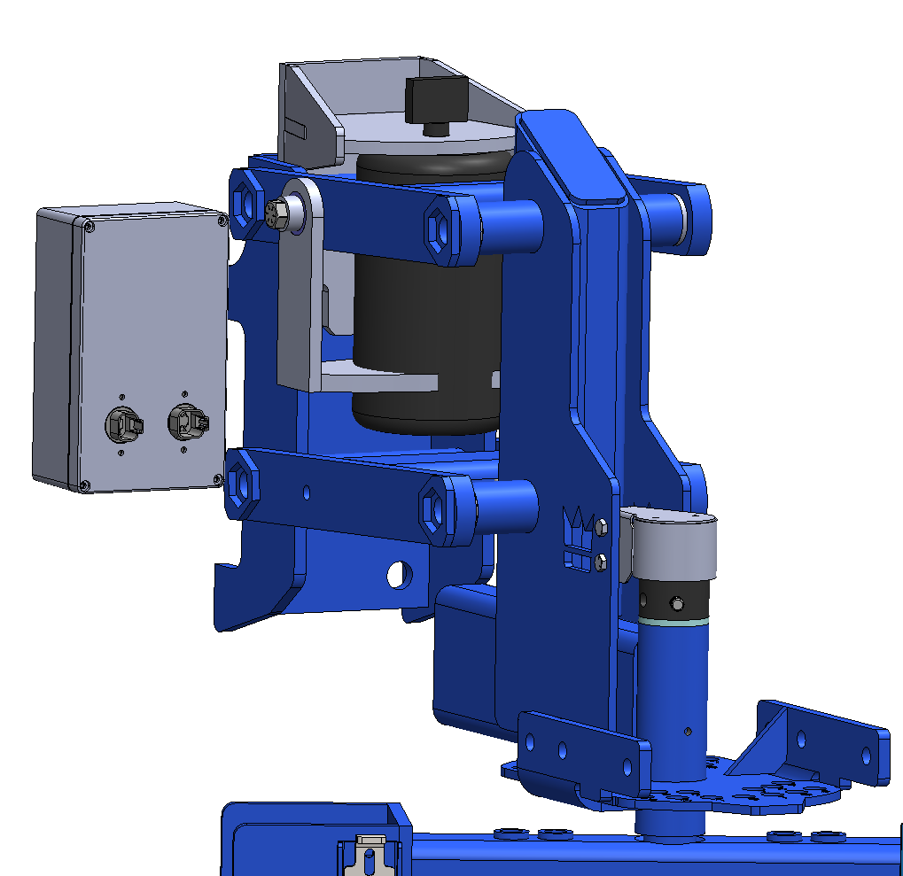
The row control module is housed in a IP67 plastic box and sits next to the row unit. I’m not sure if it would best mount to the toolbar or the row unit. In the long term I hope that it can shrink in size by a lot. The rear-facing plane has Deutsch-style bulkhead connectors for the wiring harness. The front-facing plane has Deutsch-style bulkhead connectors for the CAN bus, and 5/16” screw lugs for the power connection. Small indicator lights (probably only visible to someone on the ground) serve as diagnostics. A single pushbutton switch behind a sealing screw serves as a reset or homing switch in configuring the row unit.

User Interface
The user interface is also constructed from a IP67 plastic box. It has two encoders which serve as buttons, a 20x4 LCD module, two indicator lights, a toggle switch to turn the system on or off, a Deutsch-style bulkhead connector in the rear for power and CAN Bus, and a B-size RAM mount for in-cab mounting.
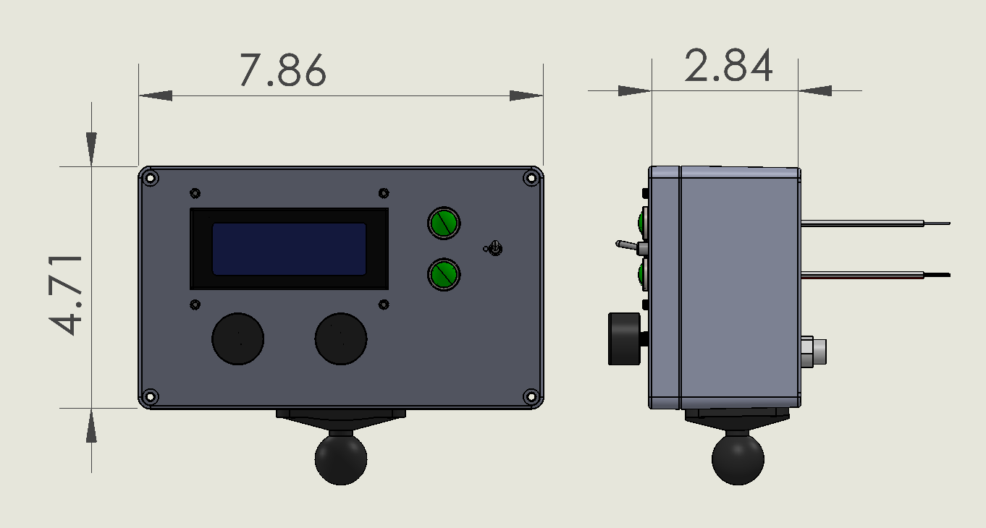

Rotary Hoe Pro User Interface
The user interface is also constructed from a IP67 plastic box. It only features two indicator lights, 6 M12 connectors (each going to 4 row units), another M12 connector for power, and a RAM mount. A power switch on the rear to turn the system on or off will be added.


