Swinging Spider Actuation Update - 12-FEB-2024

Design Overview
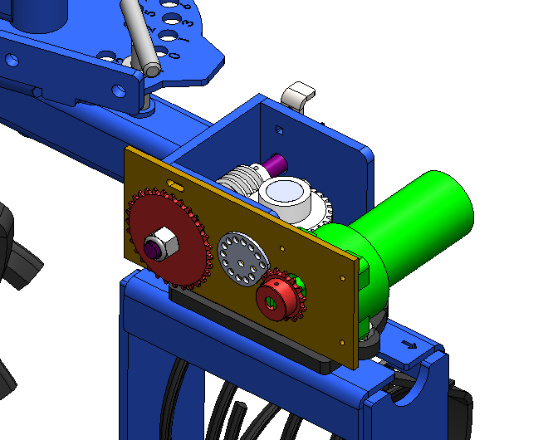
- Green motor drives a #35 chain-and-sprocket drive.
  - This is quite a span for gears, and direct driving will have a motor sticking out too far. GT2 belts are also a decent option, but #35 chain is widely available, and allows variation of the gear ratio if needed and makes the most sense at this stage of development.
- Gold plate has adjustable position to set chain tension and is locked in place with grey tensioner.
- Purple shaft is different than the existing shaft – it has a keyway to interface with the sprocket.
- Guards and shields are yet to be designed.

Motor Selection
To select a motor, a time-to-target must be picked. I started with 5 degrees of wheel adjustment in 1 second. This means a full sweep of 120 degrees would take 24 seconds.

I found that a C800 lift motor (which is what is shown in the previous image in green) commonly used in RVs should provide this target RPM and torque.
Talking with Klauber Machine and Gear pointed me to their distribution house, CSH. They sell the C800 for $190 : https://www.cshincorporated.com/k01531a800-replaces-k01285-c800-klauber-gear-motor/
Many generic versions can also be found on eBay for $60: https://www.ebay.com/itm/145602171148

