Tine Weeder Update
Thaddeus Hughes
25 SEP 2024
I. General Status
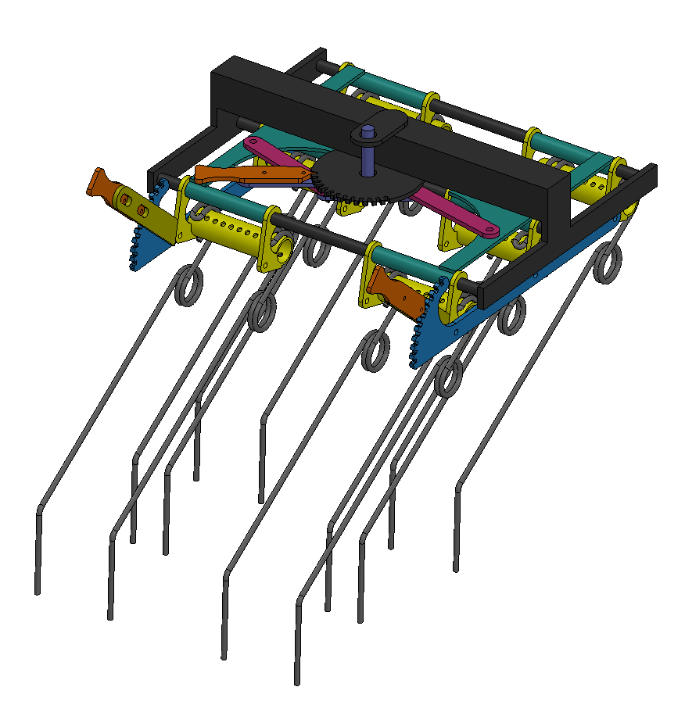
I currently have “Block CAD” of the tine weeder built – a low-fidelity mockup. This should allow us to spot potential problems without getting too far into the weeds. Hardware like bolts, pins, and bushings is not depicted.

II. Tine Gangs
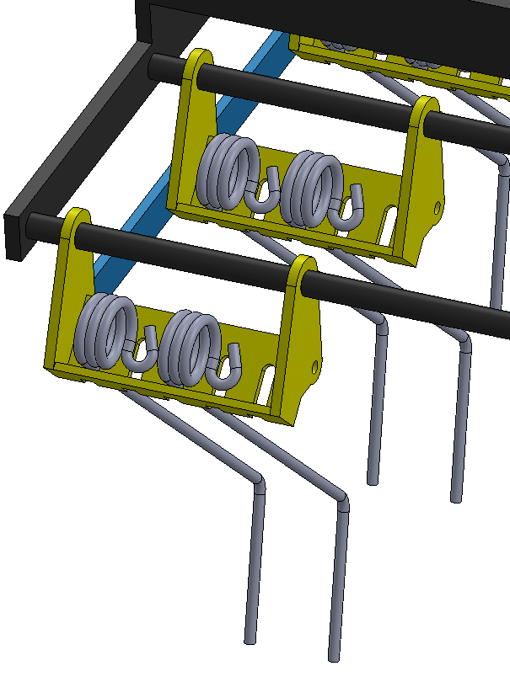
Tines would be mounted on gang brackets (yellow). These would slide and pivot on round bars of a frame (black).
The current tines are shown on the right. However, these raise a problem: the tines cannot be adjusted all the way to one side, and so, the center gap is 3” at minimum.
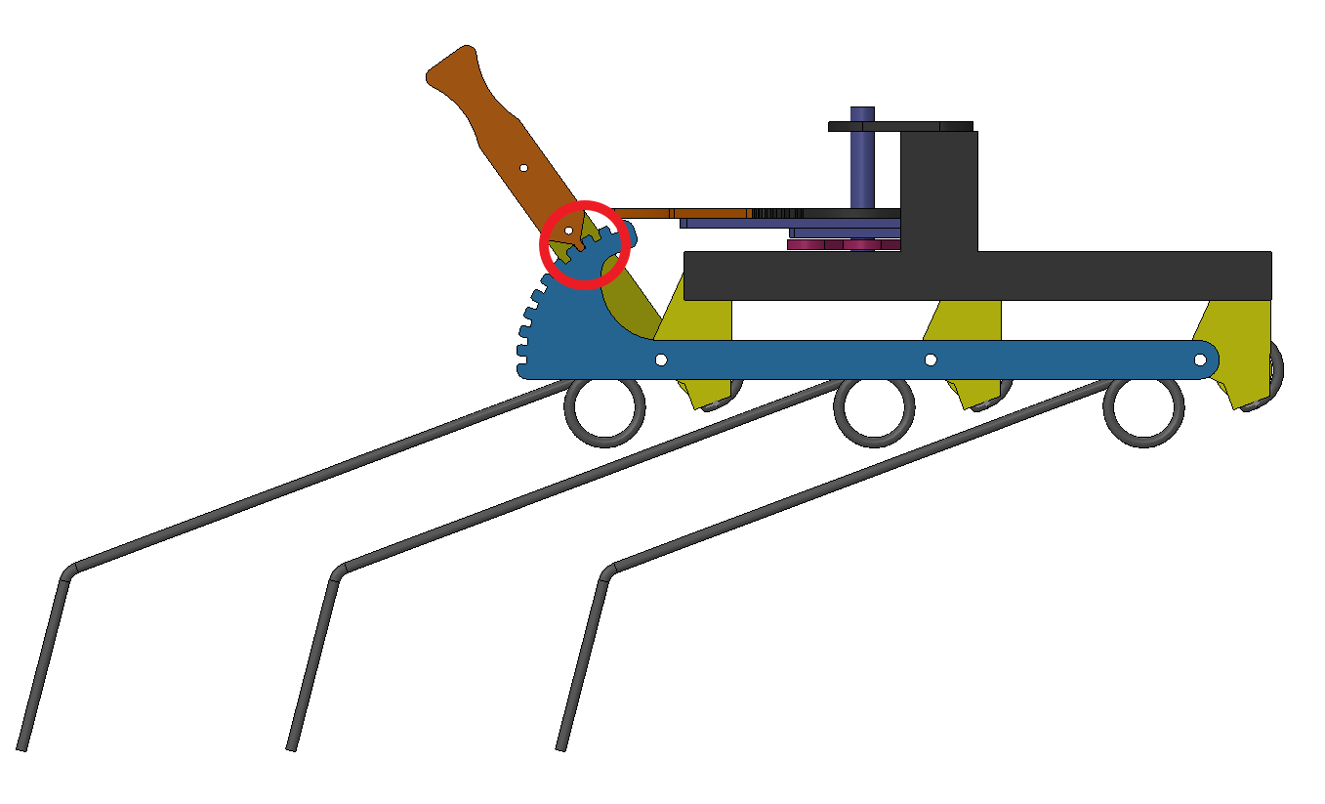
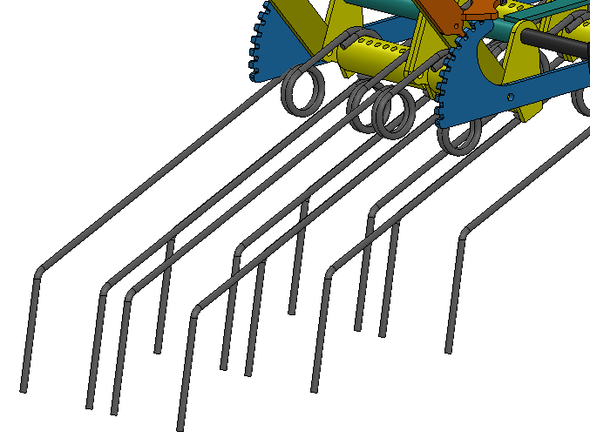
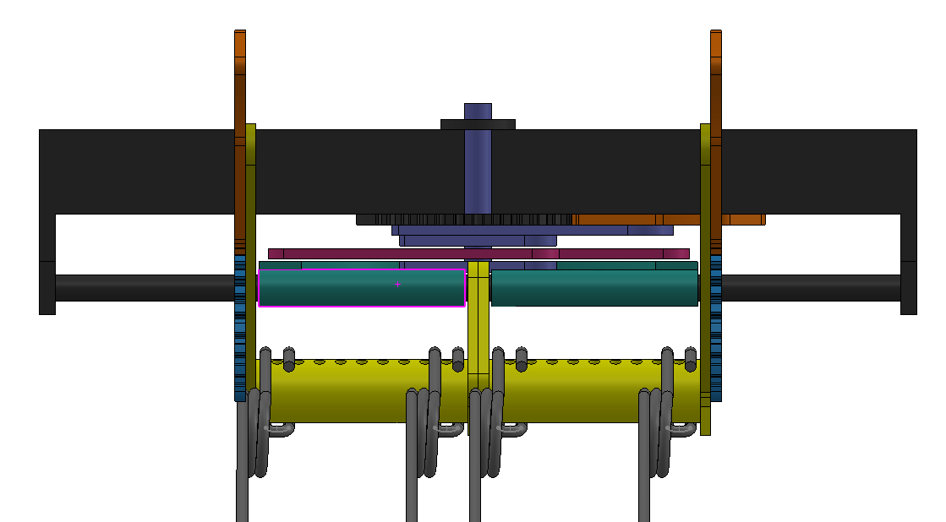
We could use a tine design like Einbock’s. This solves the gap problem, but presents another: the adjustment cannot go to the most shallow angle.
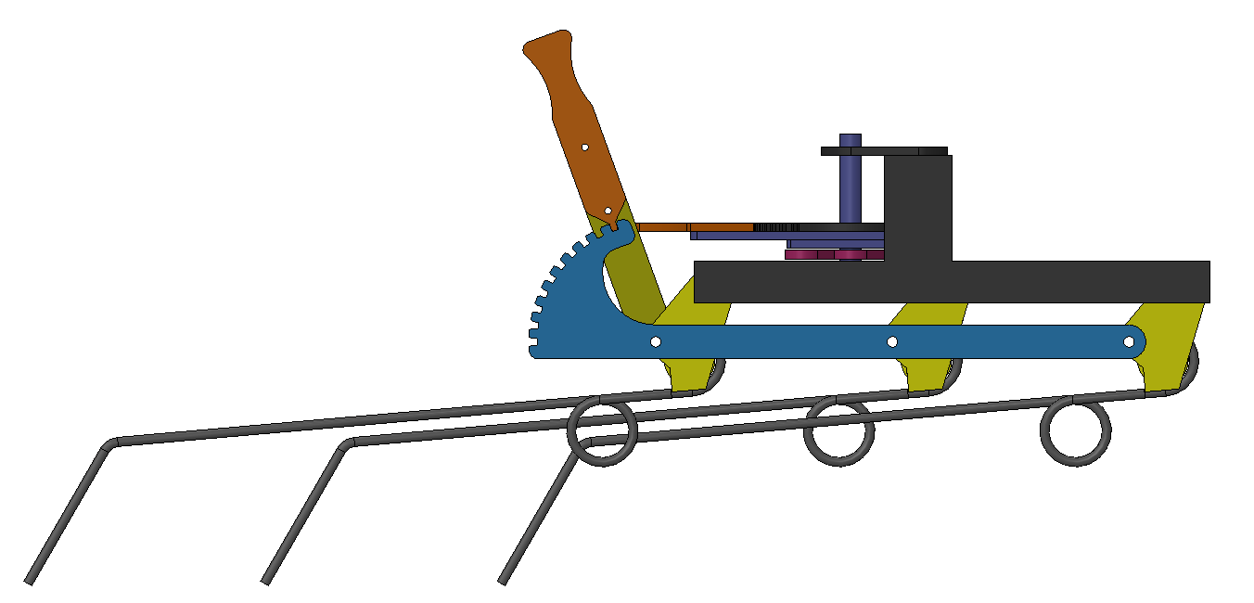
A custom tine that “flips around” the mounting bend of the tine would work, so long as the tines are staggered from each other. Or, the loop could be flipped to the top side.

III. Angle of Attack Adjustment
To package the spacing adjustment better, the angle of attack adjustment was moved to the underside. Then, to make adjustment of angle of attack faster, a different locking mechanism is used.
The adjustment lever uses two of the same bistable compliant latching mechanism as the Swinging Spider’s locking fork. To operate it, the user would pull out on the handle (orange), rotate the lever into the correct position, then push the handle back in. The plastic clip would keep the handle in the latched or unlatched position.
Instead of the plastic clip, an extension spring could be used, so that the handle would by default be in the latched position.
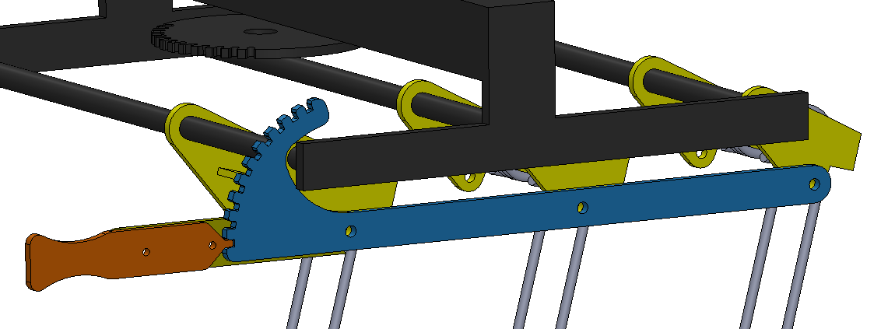
Tines fully down, adjustment in latched position
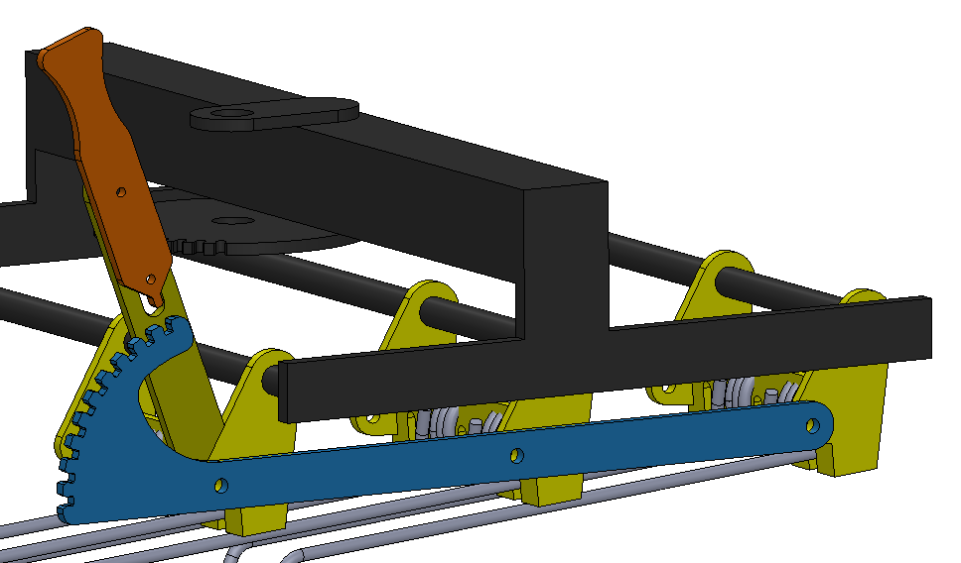
Tines fully up, adjustment in unlatched position

IV. Center Spacing Adjustment
The center spacing is set by a linkage. The user handle for this linkage uses the same pull-to-unlatch, push-to-latch mechanism as the angle of attack. This linkage connects to teal spreaders on both sides, which move the tine gangs in and out.
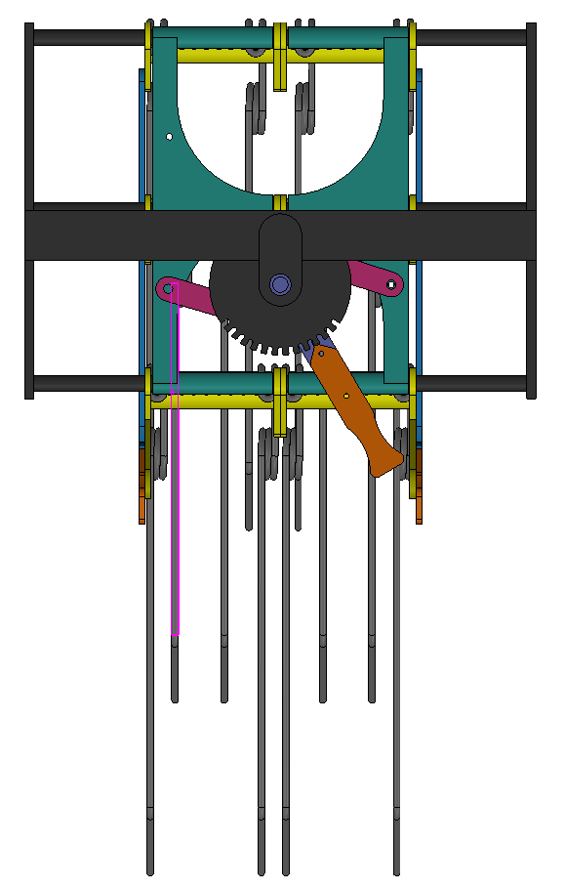
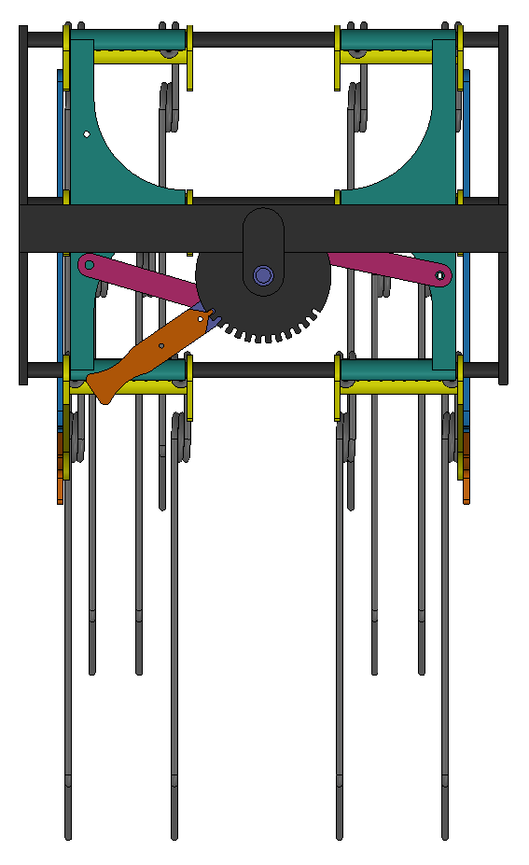
The adjuster notches have a resolution of 5/8” at the coarsest. Middle tines are 1” center-to-center when fully closed, 7” when fully spread.

V. Problems and Improvements
- The custom tine concept may not be manufacturable (I’m not intimately familiar with spring-winding equipment). It could be made more manufacturable by flipping around the attachment loop, but that would bias the tine further to the left.
- The current tines could be made to work by manufacturing a left-hand version of them.
- There are many points of sliding or rotating contact. Some may need bushings, others maybe not as much. Low-cost plastic bushings (like igus G-series) could be a better solution than polygon’s heavy-duty bushings. Locations of movement include:
  - On each gang (yellow) – 12 total
  - Each watt link (magenta) – 4 total
  - Each AOA adjustment pivot on gants – 6 total
  - Main center spacing handle – 2 total
  - Spreaders – 12 total
- Adjustment for center spacing is not linear – need to “translate” the linkage positions
- Are the bistable latching mechanisms used on the Swinging Spider strong enough for this application, especially the shoulder bolts?
- Is 5/8” adjustment resolution for center spacing sufficient, or does it need to be finer?

