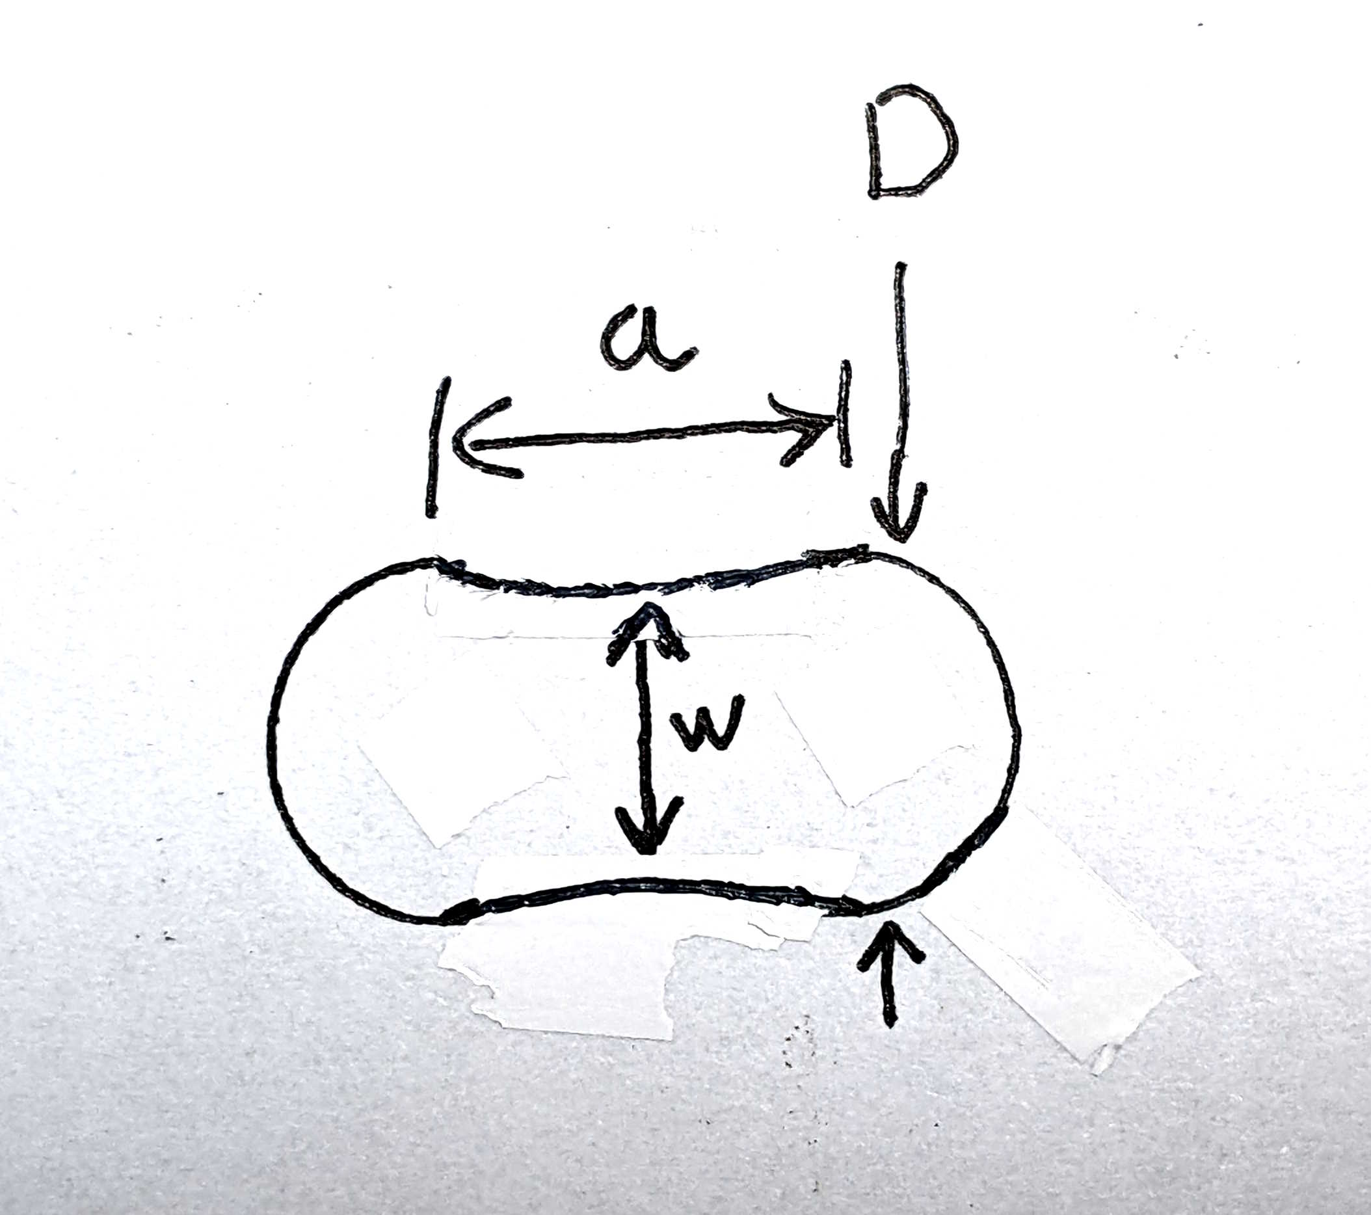
Bistable Slot Investigation
Thaddeus Hughes – 24 MAR 2025
I made seven different slots, and tested them with the same plastic insert and shoulder bolt (diameter .310”). I measured how much force was required to actuate them with a kitchen scale (this was quite rough and should not be taken as a precise measurement).
Results are as follows (dimensions in inches, forces in pounds):
ID | a | w | D | F
7 | 0.510 | D | 0.4930 | 7
5 | 0.500 | D | 0.4950 | 6
1 | 0.500 | D | 0.4980 | 5
2 | 0.500 | D | 0.5000 | 3
3 | 0.500 | D | 0.5015 | 1
4 | 0.500 | D | 0.5040 | 0.3
6 | 0.500 | 0.4955 | 0.4995 | 4
No steel – bare plastic piece |  |  |  | 0.3

Actuation force has a roughly linear relationship – more squeeze, more force required. Every thousandth of an inch adds a pound to half pound of force. However – once there is no longer a press fit, the force is nearly the same as if there was no steel retainer at all – about 4-5 ounces. So, some amount of press fit is desirable.

Adding a press fit can cause some difficulty in installing the slot, if the same center-to-center distance (a) is maintained. Increasing it even by 0.01” makes installation significantly easier, as is the case with slot #7.

A figure-eight shape somewhat helps installation but not as much as lengthening the slot. It performs similarly to as if the slot was just narrower.

