Swinging Spider Improvements
For Jason Mauck #FarmWeird
Thaddeus Hughes - 09 DEC 2024
Here are a ton of ways to stiffen the pivot points at both the center pivot and secondary pivot. A lot of them are not very good (either fussy, way too complicated, or require blowing up the entire design), but for completeness and brainstorming, I’ve left them in.
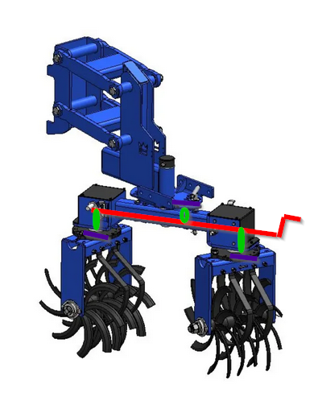
- Bolt Flange – simply have a bolt that can be tightened down against a slot.
- Over-center latch – use a over-center latch to act as a brake (or a locking pin). The latch could be mounted to either side of the mechanism, and strike the other. It may be possible to ‘gang’ these latches together so that they can be driven all at once.
- Center-shaft cam latch (image right) – an axle running along the length of the Swinging Spider has three cams (green) on it which push against the flanges on the spider wheels or the main arm.
- Centerlocking Nut – tighten down the pivot point. This could be done to the center pivot easily, but the secondary pivot would require removing or rethinking the cover. Could also use a quick-release lever.
- Shaft clamp – alongside the pivot point(s), a clamping shaft collar is machined into or welded onto the row unit. The collar is actuated via a bolt, or a quick-release lever, to keep the shaft from rotating.
- Bias spring - use a spring to constantly pull the swingarm or wheel bracket to one direction.
- Gas shock – use a gas shock to constantly push the swingarm or wheel bracket to one direction. The gas shock would not need to be particularly strong, but its built-in dampening characteristics would reduce oscillation.
- Pneumatic biaser – same idea as the bias spring or gas shock, but on a pneumatic circuit that could be electronically (or manually) controlled.
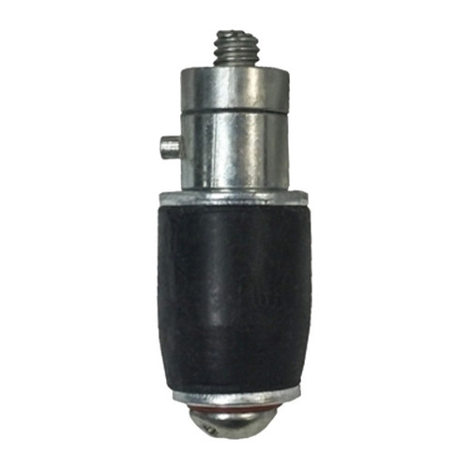
- Pin with rubber expanding plug – (aka marine plugs) – a special pin that has a rubber end, actuated by another lever, expands once it is in the hole(s) to reduce backlash.
- Pin with collet-style expanding plug – same idea, but with purely metal. See Carr-Lane Mfg.
- Adjustable gear mesh – make the worm gear mesh automatically or manually adjustable. This could be fairly easily accomplished with a small adjustment in the handle-side bushing position; the bushing could be put on a slide or eccentric adjustment.
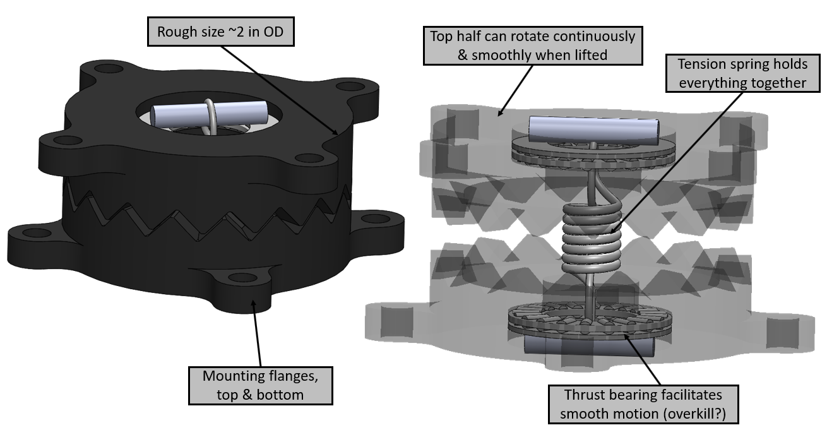
- Axial rotary detent – put a rotary detent between the upper housing and bottom flange at each pivot point. This could be designed with enough slop that when the toolbar is lifted, the detents would be dis-engaged, and adjustment would be perfectly smooth. Only once the toolbar is dropped, and vertical force is applied, would the detent transmit torque.
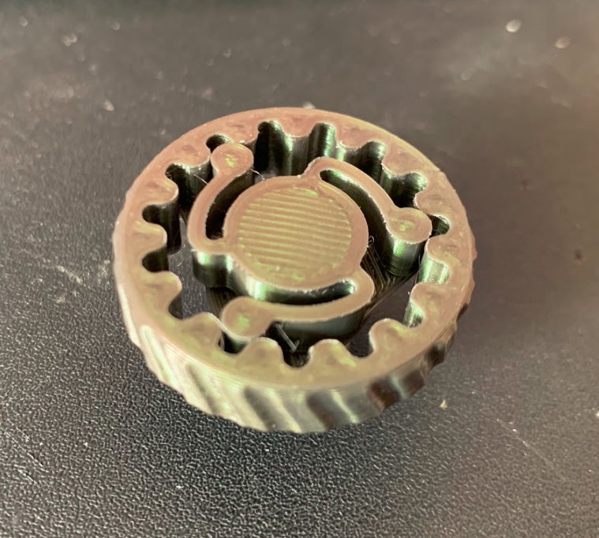
- Radial rotary detent – same placement and idea as the axial rotary detent, but does not require any vertical movement, nor would it ever truly “lock in”. It would merely dampen movement.
- Disc, drum, or band brakes – could be actuated by levers, actuators, etc.

Assessment
With so many options, it’s hard to determine which are worth trying. Here’s a table outlining some pros and cons. This is by no means definitive – it’s very opinionated.
Name | Simple / Frugal | Robustness | Efficacy | Ease of use | Actuatable
Bolt flange | Simple, cheap | Solid | Great | Wrench Req’d | No
Over-center latch | Simple | Solid | Great | Easy | No
Center-shaft cam | Kinda complicated | Likely | Good | Very easy | No
Centerlocking | Somewhat | Solid | Dubious | Easy w handle | No
Shaft clamp | Somewhat | Solid | Dubious | Easy w handle | No
Bias spring | Somewhat | Solid | Likely | Safety hazard | Somewhat
Gas shock | Somewhat | Not great | Likely | Difficult | Somewhat
Pneumatic bias | Complicated, $$$ | Fussy | Likely | Easy | Yes
Rubber pin | Simple, cheap | Dubious | Good | Easy | No
Collet pin | Simple, but $$$ | Solid | Great | Easy | No
Adjustable mesh | Simple, cheap | Solid | Unsure | Zero impact | Yes
Axial detent | Somewhat | Debris | Dubious | Zero impact | Depends
Radial detent | Somewhat | Debris | Dubious | Easy | Yes, depends
Brake | Complicated, $$$ | Fussy | Good | Depends | Pneumatically?

- I don’t know if the center-shaft cam can even integrate into the swinging spider. If it does, it’s a very attractive option because it only has one point-of-interface.
- If the axial detent mechanism works, and doesn’t jam up, it should be excellent, as it poses no impact to the user. The radial detent is an interesting option as well if we don’t need to truly lock things in place.
- If putting an adjustment mechanism on the mesh works, it should be excellent, as it poses little impact to the user (perhaps some service over time), and it doesn’t interfere with actuatability at all.
- In terms of making a rock-solid mechanism for little engineering effort and thought, nothing will beat a bolt flange. Making it an over-center latch instead of a bolt will keep operation tool-less.
- A collet-style locking pin would be a great drop-in upgrade for the swingarm. The only problem is the off the shelf ones cost $200. Perhaps there’s different sources. https://www.carrlane.com/product/alignment-pins/expanding-pins/expanding-pins-cam-handle/cl-10-exp-300
Other thoughts:
- If we want to put something like a duoseed, or some other implement that goes purely in the straight-ahead position, oscillation or at least its ill effects can be mitigated by simply mounting the parts of the unit that make ground contact behind the pivot point – just as a weathervane has its vanes behind the pivot point.
Quick-slide toolbar
We could make a highly adjustable and reconfigurable toolbar. This would allow variance not just of the width of rows, but the spacings on which the rows are.

Hatzenbichler uses a custom-shaped double-dovetail toolbar that allows for row units to simply clamp onto half of the bar. The row units can simply be unbolted and slid over. Because the mounting hardware does not wrap around, the row unit can be placed at any arbitrary location on the toolbar. This effect could be accomplished in other ways as well, not just the custom-formed tube.
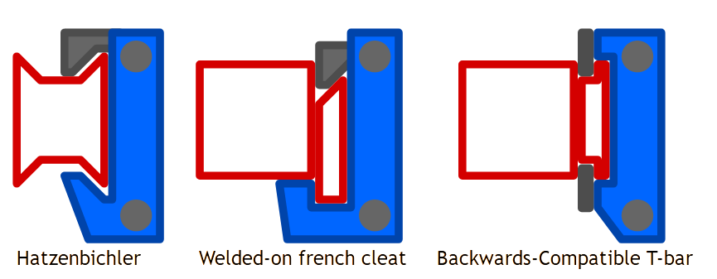
Detents, like those found on forklift fork adjustments, could be put on a regular interval such as 2.5” to help in quickly locating the row unit at the right location.
The backwards-compatible T-bar would simply be a welded on wide “T” shape. Existing row units designed for a U-bolt could be bolted into place with wide nuts.
There’s still a lot of weight hanging off the back of such a row unit. Plastic guide surfaces could be employed, but these designs will probably never be as robust as a U-bolt around a box tube, or as smooth and quick as the swinging spider.

