Overall Picture
We’re developing self-propelled livestock shelters for multiple purposes – from homesteaders who want to do rotational grazing with less effort to row crop farmers who want to integrate livestock into their farm and do ‘biohacking’ by increasing biodiversity and playing with sunlight ratios.

I’m taking over the development after turmoil with contract engineers / manufacturers, and realizing that drastic cost-down measurements are needed to make this viable.

Website: https://thestockcropper.com/
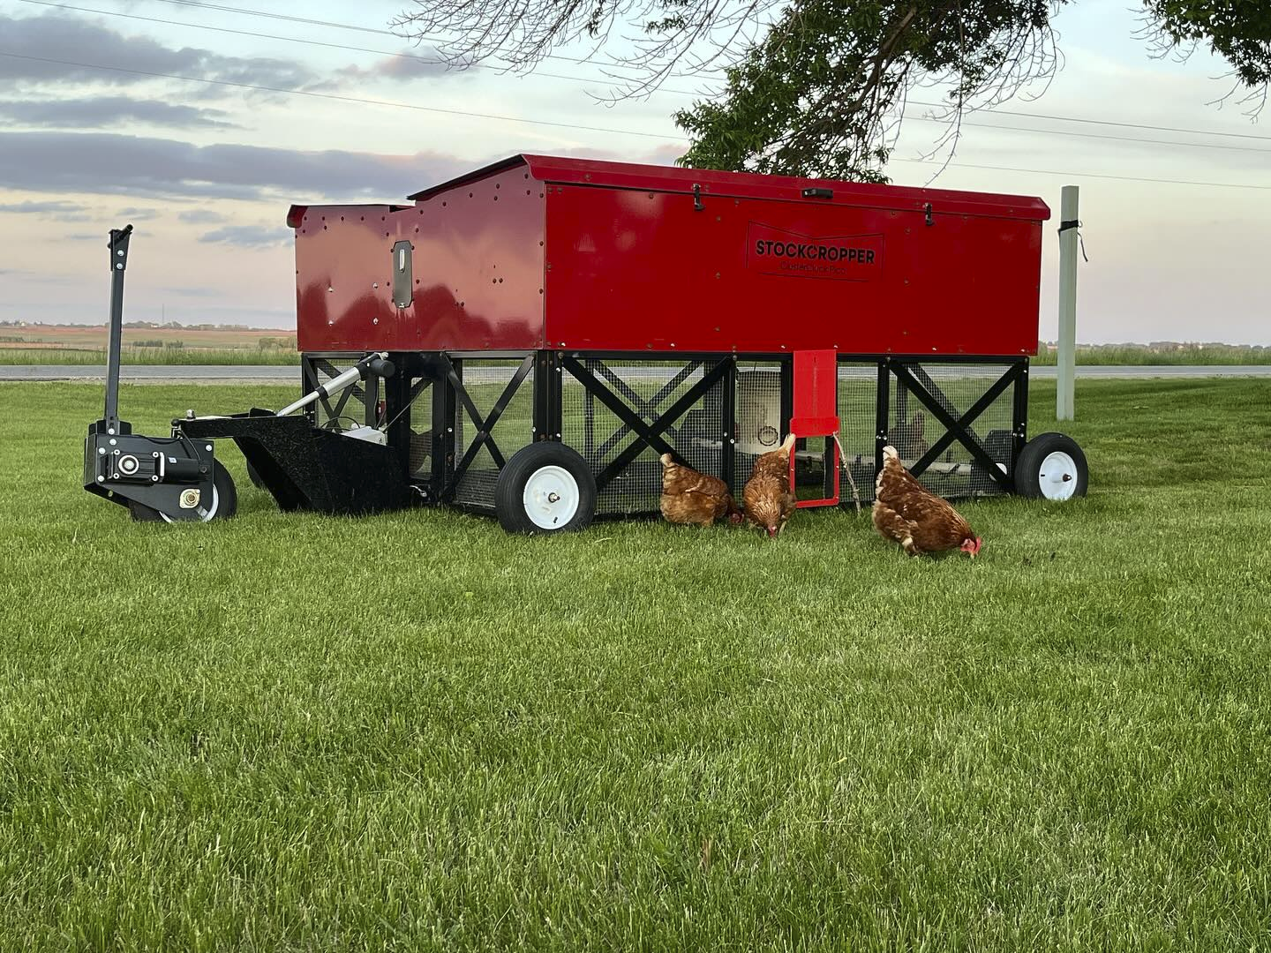
We aren’t going for high-tech whiz bang gadget features. We are going for bulletproof, owner-servicable (right to repair mindset), and low-cost. Right now we are focusing on building a highly robust drive unit.

Timeline
Our immediate goal is to deliver 20+ pilot units in the Spring of 2026. It’s tight. This means we want to use as much off-the-shelf as possible.

System Design
The electronics controls are split into two modules, with these components:
- Control Box
  - ESP32-WROOM as MCU
  - Relay H-bridges for Brushed DC motor control
    - Two 20A channel
    - One 50A channel
  - Current sensing on H-bridges
  - Real-time clock
  - Connect to limit switches & encoders (via AT06-12S bulkhead)
  - CAN transceiver to comm with UX box and future add-ons (via AT06-4S bulkhead)
  - Solar charging circuit (maybe? May just make this a separate item)
- UX Box
  - ESP32 as MCU
  - 4-5 tactile switches
  - 1602 LCD module
  - CAN transceiver to comm with control box

I could make this alternative architecture work if I don’t need current limiting and can live with the messier cabling:

Dumb CB:
- Dumb Control Box
  - Relay H-bridges for Brushed DC motor control
    - Two 20A channel
    - One 50A channel
  - Solar charging circuit
- < - cable is 8 pins: 12V, GND, M1, M2, M3, M4, M5, M6 ->
- UX Box
  - ESP32 as MCU
  - 4-5 tactile switches
  - 1602 LCD module
  - Real-time clock
  - Connect to limit switches & encoders
  - Total IOs
    - 8 (or 2?) DO – screen
    - 6 DI – buttons
    - 2 DI – limits
    - 6 DO – motors
    - 1 AI – voltage
    - total: 14 (or 8) DO, 8 DI, 1 AI (17 – 23 total)

Dumb CB with sensors to it:
- Dumb Control Box
  - Relay H-bridges for Brushed DC motor control
    - Two 20A channel
    - One 50A channel
  - Solar charging circuit
  - Passthru for limit switches
- < - cable is 12 pins: 12V, GND, M1, M2, M3, M4, M5, M6, S1, S2, S3, S4 ->
- UX Box
  - ESP32 as MCU
  - 4-5 tactile switches
  - 1602 LCD module
  - Real-time clock
  - Connect to limit switches & encoders
  - CAN bus for connecting future accessories

Dumb UI:
- Dumb Control Box
  - Relay H-bridges for Brushed DC motor control
    - Two 20A channel
    - One 50A channel
  - Solar charging circuit
- < - cable is 16 pins: 12V, GND, <8 for screen>, <6 for buttons> ->
- UX Box
  - ESP32 as MCU
  - 4-5 tactile switches
  - 1602 LCD module
  - Real-time clock
  - Connect to limit switches & encoders

No-screen UI:
- Control Box
  - ESP32-WROOM as MCU
  - Relay H-bridges for Brushed DC motor control
    - Two 20A channel
    - One 50A channel
  - Current sensing on H-bridges
  - Real-time clock
  - Connect to limit switches & encoders (via AT06-12S bulkhead)
  - CAN transceiver to comm with future add-ons (via AT06-4S bulkhead)
  - Solar charging circuit
  - 4 tactile switches
  - 1602 LCD module
- ← 5 pin cable M1 M2 M3 M4 GND →
- UX Box
  - 4 tactile switches

I’m not doing any proportional motor control (i.e. using FETs) because everything is low speed, and relays are foolproof to design around.

What I’ve Done

I’ve taught myself KiCAD and (mostly) successfully made a few boards for a few prototyping projects (had manufactured by PCBway, and assembled myself, all THT components). I have a control box I made that will work well enough to vet the mechanical components of the prototype I’m building right now.

I’m going to need to rework that board so it meets the architecture discussed previously.

What I Need
- Basic architecture review – do these seem like reasonable decisions?
  - The ESP32 seems like a very popular MCU and they’re really cheap but should something else be considered?
  - Over 2m, is CAN needed? Or can I do I2C? I have a feeling CAN will be more future-proof and may go with it on that basis, but…
- Detail review – am I following best practices? (do I need optoisolators or is
- Potential design help
  - Solar charging circuit

